User Control in ASP.NET
User controls are one of ASP.NET methods to increase reusability of code, implement encapsulation and reduce maintenance. User control is similar to web page. Both web pages and user controls contain HTML elements and markup for web controls. Some tags, like <html>, <head> or <form> cannot be used in web user controls.
User controls are saved with .ascx extension, instead of .aspx for web pages. User controls can use code behind feature like web pages. Code behind file of web user controls ends with .ascx.vb. Markup code of user controls starts with @Control directive. Simplest web user control could contains only static HTML, like in this example:
<%@ Control Language="VB" CodeFile="WebUserControl.ascx.vb" Inherits="WebUserControl" %>
<p>Hello, I am very simple <b>web user control</b> with static HTML only.</p>
This web user control could be used when you need to repeat same code on many pages. Good examples are page footer, header or some kind of site navigation. Except static HTML code, web user controls could contain web controls. You can simply drag and drop items from toolbox to user control. Like any other control, user controls can have properties, methods and events which make them very useful.
Advantages
If user control solves more general problem, like progress bar or data pager control then can be useful on many different web sites. On this way, user controls can provide more stable and tested code.

How to create web user control
All user controls are derived from the System.Web.UI.UserControl class. UserControl and Page classes both inherits from TemplateControl class. You can add web user control to existing web site project, in Visual Studio menu go to WebSite -> Add New Item..., like in image bellow
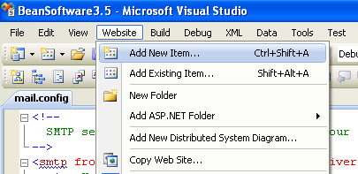
New dialog will appear. To create new web user control, select web user control template, like in next image. Choose a name for your control and click Add.
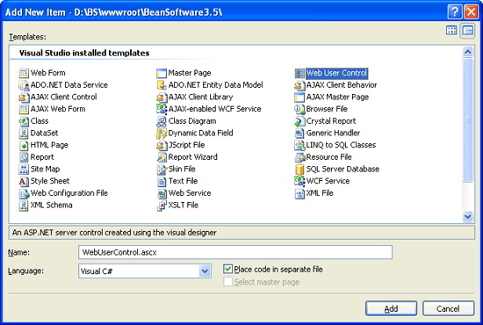

How to add web user control to ASP.NET web page
To add web user control to web page, we need two lines. First, we need to register user control with Register directive on top of the page:
<%@ Page Language="VB" AutoEventWireup="true"Â CodeFile="Default.aspx.vb" Inherits="_Default" %>
<%@ Register tagprefix="bean" Tagname="footer" src="~/footer.ascx" %>
With Register directive we define user control on page. The important parameters are:
TagPrefix: prefix for user control tag. This prefix will be used in markup code later.
TagName: tag name of user control tag.
Src: path to .ascx file.
After registration with Register directive, you can place user control inside web form with tag formatted as <tagprefix:tagname, like this:
<bean:footer runat="server" id="MyUserControl" />

Registering user controls in web.config
If you'll use user control on many pages on web site then you can register control in web.config file. On this way you can use user control in complete web site without need to register it on every page. You can do this in <controls > section with code like this:
<configuration>
<system.web>
<pages>
<controls>
<add src="Footer.ascx" tagPrefix="bs" tagName="footer" />
</controls >
</pages >
</system.web>
</configuration>

